MGT 40750 – Quantitative Decision Modeling

Spring 2017

**Final Exam (Type A)**

**Time: March 8, 2017 (Wednesday)**

**Name: ______________**

**NetID: ______________**

This is an open-computer/closed-book/closed-note exam. A one-page two-sided cheat sheet is allowed.

Please show all work and submit your Excel files on Sakai in order to receive partial credit.

Good luck!

**Grade:**

Question 1: _____ / 30

Question 2: _____ / 35

Question 3: _____ / 27

Question 4: _____ / 33

**Total: _____ / 125**

# Question 1: Grocery Store

*(You don’t need to use the computer for this question.)*

The following is a variation of the grocery store example we discussed in class:

A truck from the SuperBread bakery drops off several types of loaves of freshly baked bread at the grocery store *every day*. For each type of bread from the bakery, there is designated space on the shelves of the store and in the back of the store (the total space allotted to each type of bread depends on the demand for that type of bread). The driver drops off enough loaves of each type so the designated space for each type of bread is filled. The store has designated enough space to hold 35 loaves of SuperWheat bread. An examination of sales records (at times when there is SuperWheat on the shelf) shows that the time between purchases of a loaf of SuperWheat is .3 hours on average (with an exponential distribution). The store is open 12 hours per day, 7 days per week.

Management wants to determine the minimum amount of storage space that should be designated for SuperWheat bread so that 90% of the customer demand is satisfied. The model was run 50 times, each for 30 simulated days with storage spaces of 35, 40, and 45 loaves. The results are given on the next page. Time units represent *hours*.

a. (14 points) Specify the SimQuick model below (Use 35 loaves as the designated space here):



|  |  |
| --- | --- |
|  | b. (4 points) Based on the results, how much storage space do you recommend? Why?  c. (4 points) What is the overall mean number of hours loaves spend on the shelf when the storage space is set at 35 loaves?  d. (4 points) What is the overall mean number of loaves sold during the simulated 30 days when the storage space is set at 35 loaves?  e. (4 points) What is the overall mean percentage of satisfied customers during the simulated 30 days when the storage space is set at 35 loaves? |
|  |
|  |

# Question 2: Assignment of Consultants

A consulting firm needs to assign 15 consultants to 3 projects. The constraints are listed below:

* Each project requires 5 consultants and each consultant can only be involved in 1 project.
* Consultants 5 and 15 cannot work on the same project.
* Either consultant 4, or consultant 12, or both have to work on project 1.

Probability of success for each project can be estimated by computing the squared value of the average expertise of selected consultants. For example, if consultants 1, 2, 3, 4, and 5 are selected for project 1, then the probability of success for project 1 is ${\left(\frac{0.6+0.5+0.7+0.8+1}{5}\right)}^{2}$.

The consulting firm would like to maximize the overall probability of success of all three projects.

a. (15 points) Specify all necessary formulas and numbers in the following Excel worksheet:

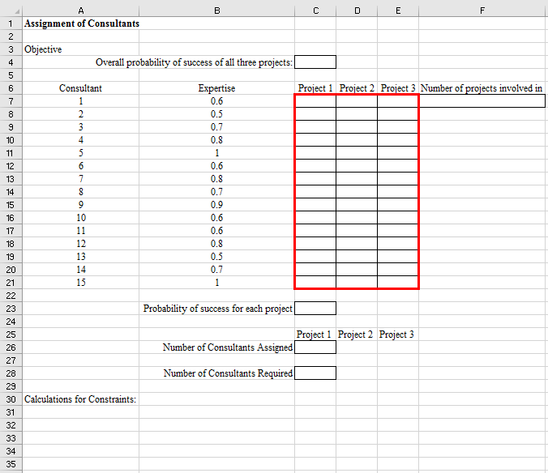



b. (14 points) Specify Solver.

Set Objective: _________

To: ○ Max ○ Min ○ Value of: _________

By Changing Variable Cells: ______________________________________________________

Subject to the Constraints:

|  |
| --- |
|  |

□ Make Unconstrained Variables Non-Negative

Select a Solving Method: ____________

c. (6 points) Based on your results, what’s your recommended assignments for the consultants?

*You only need to record all the 1’s (no need to record the 0’s).*

|  |  |  |  |
| --- | --- | --- | --- |
| Consultant | Project 1 | Project 2 | Project 3 |
| 1 |  |  |  |
| 2 |  |  |  |
| 3 |  |  |  |
| 4 |  |  |  |
| 5 |  |  |  |
| 6 |  |  |  |
| 7 |  |  |  |
| 8 |  |  |  |
| 9 |  |  |  |
| 10 |  |  |  |
| 11 |  |  |  |
| 12 |  |  |  |
| 13 |  |  |  |
| 14 |  |  |  |
| 15 |  |  |  |

# Question 3: Reservation Management

*(You don’t need to use the computer for this question.)*

Consider the following variation of the reservation management example discussed in class: In this problem, the airline would like to minimize its total cost which consists of both cost of lost sales and cost of bumping. Lost sales occur when consumer demand is higher than the number of tickets sold while bumping occurs when there are more passengers wanting to board than the available seats.

The following is the @Risk Model in Excel:

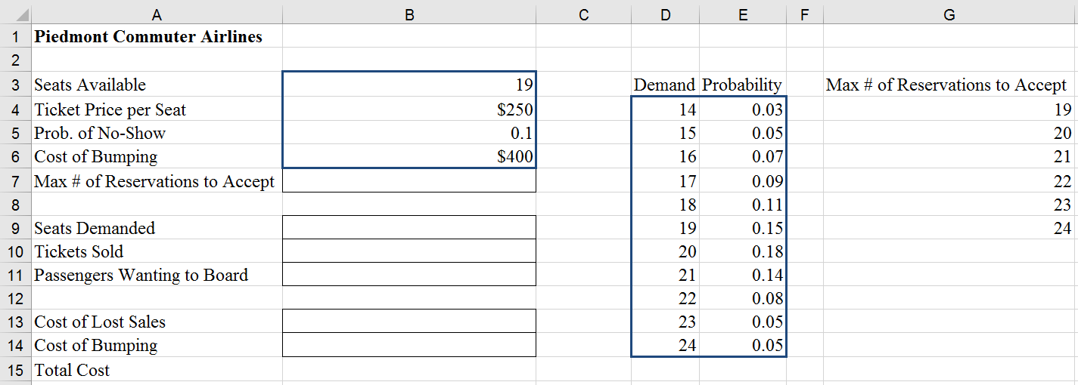

=RiskOutput(“Total Cost”)+B13+B14

a. (3 points each) Specify the following formulas (note that the rows and columns have shifted a little compared to the class example):

|  |  |  |  |  |  |
| --- | --- | --- | --- | --- | --- |
| B7: | |  | | --- | |  | | B9: | |  | | --- | |  | |
| B10: | |  | | --- | |  | | B11: | |  | | --- | |  | |
| B13: | |  | | --- | |  | | B14: | |  | | --- | |  | |

b. (4 points) Set up @Risk parameters below:

Iterations = _________

Simulations = _________

c. (5 points) Based on the following @Risk output results, what’s the optimal maximum # of reservations to accept? Explain your answer.

|  |  |  |  |  |  |  |  |  |
| --- | --- | --- | --- | --- | --- | --- | --- | --- |
| Name | Cell | Sim# | Min | Mean | Max | 5% | 95% | Errors |
| Total Cost | C16 | 1 | $0 | $293 | $1,500 | $0 | $1,000 | 0 |
| Total Cost | C16 | 2 | $0 | $192 | $1,650 | $0 | $1,000 | 0 |
| Total Cost | C16 | 3 | $0 | $157 | $1,800 | $0 | $900 | 0 |
| Total Cost | C16 | 4 | $0 | $154 | $1,950 | $0 | $900 | 0 |
| Total Cost | C16 | 5 | $0 | $159 | $2,100 | $0 | $1,050 | 0 |
| Total Cost | C16 | 6 | $0 | $163 | $2,250 | $0 | $1,050 | 0 |

# Question 4: Roulette

Consider the following variation of the optimal target hitting strategy (i.e., bet the amount so that you can hit the target as soon as possible if you have enough money; otherwise, bet all you have) in the Roulette example we discussed in class:

* Suppose you have $100 and you would like to hit the target of $200.
* Instead of betting on Red or Black, you would like to bet on your favorite line, which includes six numbers (4, 5, 6, 7, 8, 9). The corresponding payoff ratio is 5:1.

Use @Risk to simulate the optimal target hitting strategy of trying to hit the target as soon as possible.

a. (21 points) Specify all necessary formulas and numbers in the following Excel worksheet:

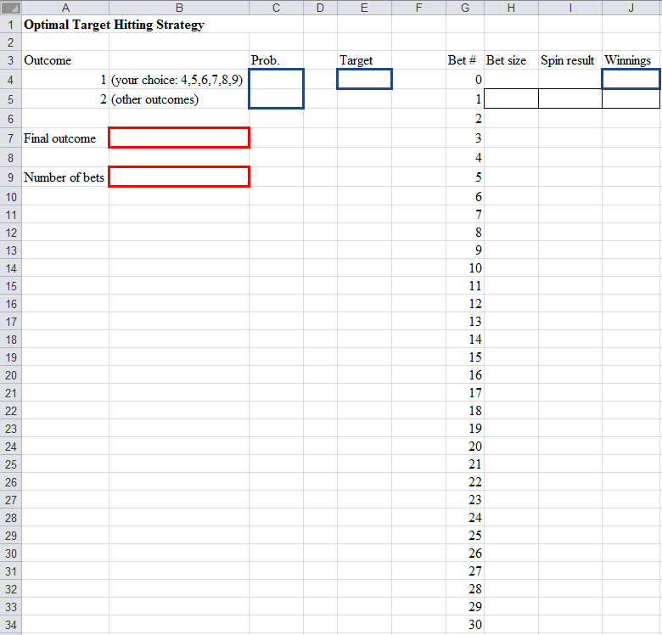

Run your @Risk model and answer the following two questions based on the simulation results.

b. (6 points) What’s the probability of hitting the target?

c. (6 points) Suppose you would stop betting either when you hit the target or you lose all of your $100. What’s average number of bets you could place?